PHASE RULE AND PHASE DIAGRAM

Phase rule
American physicist Willard Gibbs as early as 1874 gave a relationship mathematically governing all heterogeneous equilibria that is known as Phase rule or Gibb’s Phase rule as following: F = C − P + 2
Where F = degrees of freedom, C = components (number of components in a system) and P = number of phases.

Characteristics of Phase rule
- It deals with the behavior of heterogeneous systems.
- It is applied to predict qualitatively by means of a diagram the effect of changing pressure, temperature and concentration on a heterogeneous system in equilibrium.
- It allows us to predict the number of stable phases that may exist in equilibrium for a particular system.
Homogeneous system: A system consisting of one phase is called a homogeneous system.
Heterogeneous system: A system consisting of two or more phases is heterogeneous system.

Phase (P)
Definition: A phase is a form of matter that is homogeneous in chemical composition and physical state. Typical phases are solid, liquid and gas. Two immiscible liquids (or liquid mixtures with different compositions) separated by a distinct boundary are counted as two different phases, as are two immiscible solids.

Examples-
- A system containing liquid water is 1-phase system,
- A system containing liquid water and water vapor is 2-phase system,
- A system containing liquid water, water vapor and solid ice is 3-phase system.

More examples
- Pure substances (solid, liquid or gas): O₂, C₆H₆, H₂O etc. → 1-phase systems;
- Mixtures of gases: O₂ and N₂ →1-phase systems;
- Miscible liquids: H₂O and ethanol →1-phase system;
- Non-miscible liquids: CHCl₃ and H₂O →2-phase systems;
- Aqueous solution: NaCl in H₂O →1-phase system;
- Mixtures of solids: monoclinic and rhombic sulfur →2-phase systems; (physical properties different)

Components (C)
Definition: The number of components (C) is the number of chemically independent constituents of the system.

Examples
  - H₂O and sulfur system → 1-component system;
H₂O: three phases- solid ice, water and water vapor but one chemical individual, H₂O.
Sulfur: four phases- rhombic, monoclinic, liquid and vapor but one chemical individual.
  - Mixtures of gases: (e.g. O₂ and N₂) →1-phase, two components;
  - NaCl solution: H₂O and NaCl →1-phase, two components;

Degree of Freedom (F)
Definition: The number of degrees of freedom (F) is the number of independent intensive variables, i.e. the largest number of thermodynamic parameters such as temperature or pressure that can be varied simultaneously without affecting one another or without changing the number of phases present at equilibrium. A system is defined completely when it retains the same state of equilibrium with the specified variables.
A system F = 0, non-variant → no degree of freedom
A system F = 1, uni-variant → one degree of freedom
A system F = 2, bi-variant → two degree of freedom
Examples
- For a pure gas, F = 2;
PV = RT, if factors P and T are specified V is fixed automatically.
- For a mixture of gases, F = 3;
Composition, temperature and pressure are specified. Volume is fixed automatically.
- For Water ↔ Water vapor, F = 1;
Temperature or pressure is specified, the other is fixed automatically.

One-component systems: Phase diagrams
For a one-component system, C = 1; F = C − P + 2 = 1 − P + 2 = 3 − P
Case-1. One phase, F = 3 − P = 3 − 1 = 2; The system is bi-variant
Two variables- temperature and pressure
A single phase system is represented by an ‘Area’ on a P,T-graph.
Case-2. Two phases, F = 3 − P = 3 − 2 = 1; The system is mono-variant
One variable- temperature or pressure
A two-phase system is depicted by a ‘Line’ on a P,T-graph.
Case-3. Three phases, F = 3 − P = 3 − 3 = 0; The system is in-variant
Two variables- temperature and pressure are definite
A three-phase system is represented by a ‘Point’ on P,T-graph.

Phase Diagrams
Definition: A phase diagram is a plot showing the conditions of pressure and temperature under which two or more physical states can exist together in a state of dynamic equilibrium.
The diagram consists of (a) the regions or areas; (b) the lines or curves and (c) the triple point.
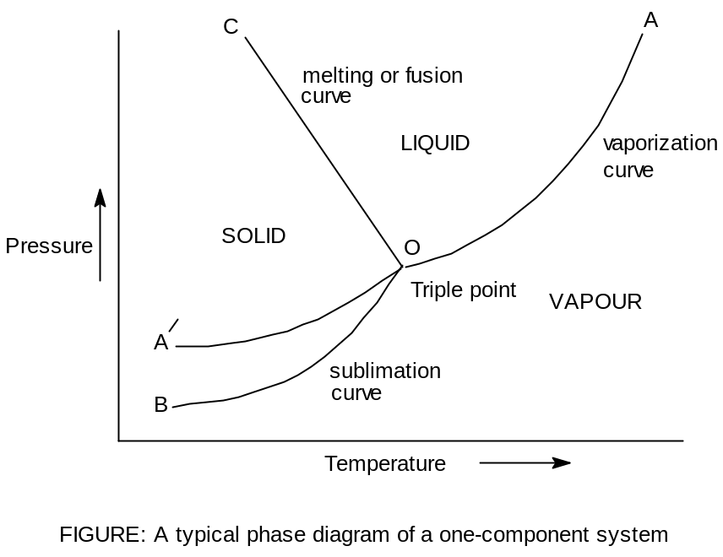

- Regions or areas:
The diagram is divided into three areas- solid, liquid and vapour.
Each of the three areas shows the conditions of temperature and pressure under which the respective phase can exist.
For one phase and one component, F = 1 − 1 + 2 = 2 ;
Thus each area of phase diagram represents a bi-variant system.

- Lines or curves:
There are three curves/lines separating the areas, showing the condition of equilibrium between any two of the phases:
  - Melting or fusion curve: Solid and liquid phases are in equilibrium, Solid  Liquid; Solid and liquid line is known as melting curve.
  - Vaporisation curve: Liquid and vapour phases are in equilibrium, Liquid  Vapour; Liquid and vapour line is known as vaporisation curve.
  - Sublimation curve: Solid and Vapour phases are in equilibrium, Solid  Vapour; Solid and vapour line is known as sublimation curve.
For two phases and one component, F = 1 − 2 + 2 = 1 ;
Thus each line of phase diagram represents a mono-variant system.

- Triple point:  
The three boundary lines enclosing the three areas on the phase diagram intersect at a common point called the Triple point.
A triple point shows the conditions under which all the three phases (solid, liquid and vapour) can coexist in equilibrium.
Solid  Liquid  Vapour
For three phases and one component, F = 1 − 3 + 2 = 0 ;
Thus at the triple point of phase diagram the system is non-variant.

SULFUR SYSTEM

It is a one-component, four-phase system. The four phases are:

(a)Two solid polymorphic forms:
(i) Rhombic Sulfur (SR)
(ii) Monoclinic Sulfur (SM)
(b) Sulfur Liquid (SL)
(c) Sulfur Vapour (SV)

The phase diagram for the sulfur system is shown in Figure.
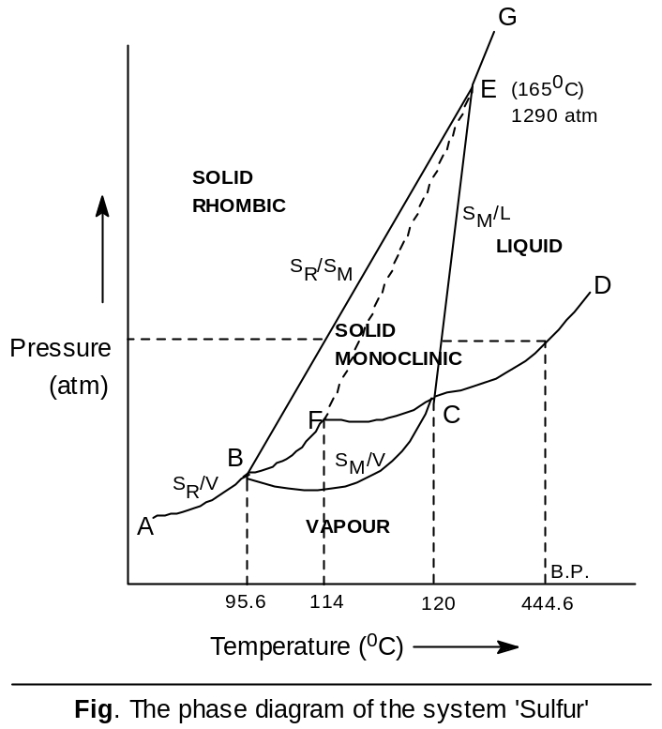

(1) The curves AB, BC, CD, BE, CE & EG:
F = C – P + 2 = 1 – 2 + 2 =1; one degree of freedom i.e. monovariant.
Curve AB, the vapour pressure curve of S_{R}
Curve BC, the vapour pressure curve of S_{M}
Curve CD, the vapour pressure curve of S_{L}
Curve BE, the transition curve, S_{R} + Q (heat energy) → S_{M}
Curve CE, the fusion curve of S_{M}
Curve EG, the fusion curve of S_{R}

(2) The triple points B, C & E:
F = C – P + 2 = 1 – 3 + 2 =0;
no degree of freedom i.e. nonvariant.
(3) The Areas:
F = C – P + 2 = 1 – 1 + 2 =2;
two degrees of freedom i.e. bivariant.
The phase diagram of the sulfur system has four areas or regions- rhombic sulfur, monoclinic sulfur, liquid sulfur and vapour.

